AFTER CARE INSTRUCTIONS-HOW TO TAKE CARE OF YOUR DRAINS
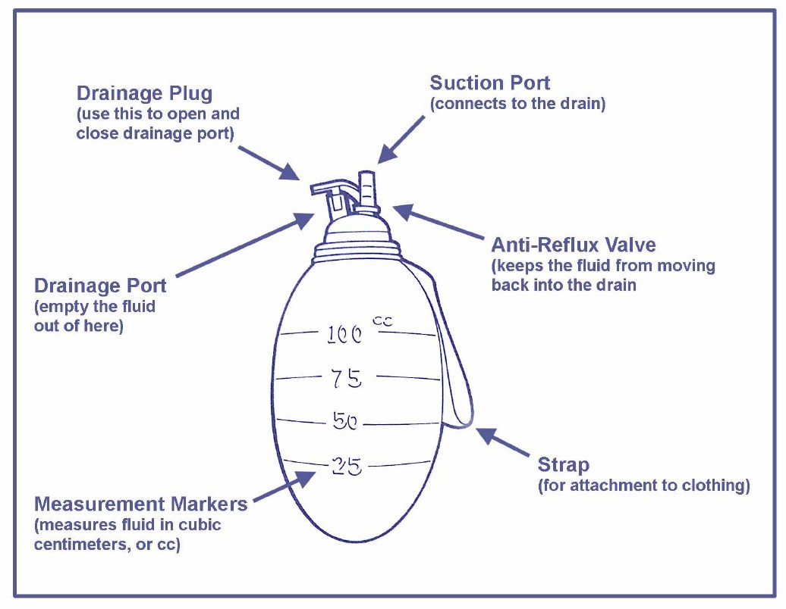T. Y. Steven Ip, M.D., F.A.C.S.

Your drain works by suction from the compressed bulb. This removes fluid from the surgical site and assistsinwoundhealing. Beforedischargefromthe hospitalyouwillbeshownhowtocareforthedrain and drain site. It is important that you follow these
instructions and record the drainage amount on the
sheets provided. You will need to bring these recordings to your next appointment with Dr. Ip and his nurse.

Care of the drain and drain site:
- The drain should be stripped every 1-2 hours while awake. Use one hand to hold the drain securely next to the insertion site and using the other hand’s thumb and forefinger squeeze all the way down the tube to the bulb. Using an alcohol wipe to strip eases this stripping motion.
- Clean area around drain with cotton swab and peroxide mixture twice daily.
- Apply antibiotic ointment with cotton swab.
- Cover with dressing as instructed by Dr . Ip.

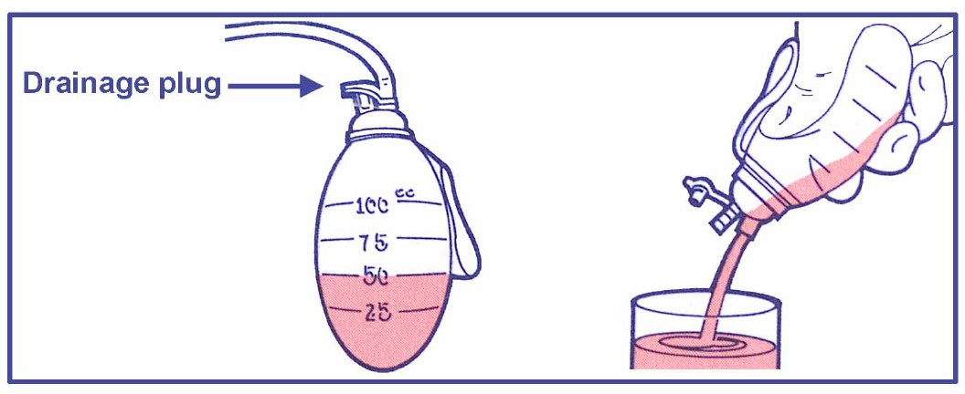To empty the bulb:
- Wash your hands.
- Hold the bulb upright (drainage plug on top).
- Remove the drainage plug to release pressure.
- Allow bulb to fully expand.
- Turn the bulb upside down and GENTLY squeeze the fluid in the medicine cup for accurate measurements in cc’s.
- 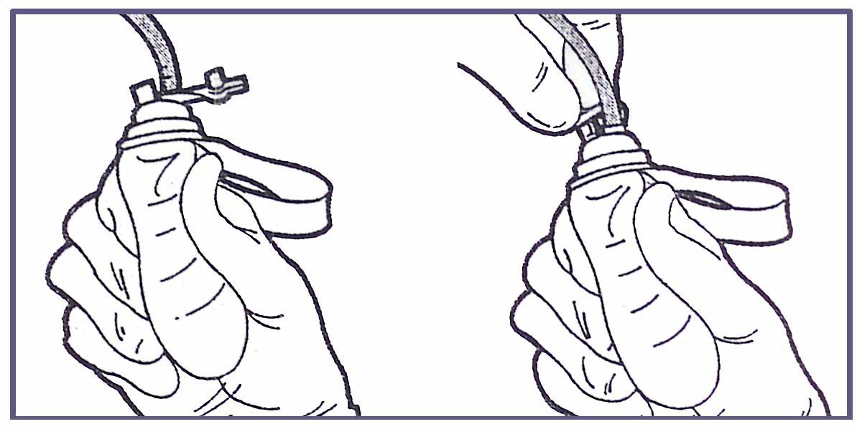Place the medicine cup on the counter.

To reactivate suction:
- Squeeze the bulb to remove the air.
- While squeezing, close drainage plug.
- Release the bulb.
- The bulb will stay collapsed or concave.
- Wash your hands.

Important
- Be sure to empty the bulb before it fills completely or the drain will not work properly.
- Keep accurate records on the amount and quality of fluid.
- Be careful to keep the drain tightly in place.
- An airtight seal is necessary between both the skin and the drain and the drain and the bulb for the system to work properly.
- Pay attention to how your wound is healing and keep accurate record for Dr. Ip.

After drain is removed.
- You may shower 24 hours after drain was removed.
- Apply antibiotic ointment with cotton swab for two days following drain removal.
- Cover with bandage for two days.
- Call if the drain site continues to drain more than 48 hours after drain removal.

Notify Dr. Ip if:
- Drain falls out.
- Change in color of fluid or unusual amounts of fluid.
- Drain becomes clogged
- Redness around the site.
- Fluids around drain site.
- Bulb does not stay flat after reactivating.

Measure and record the amount of drainage on the sheet below. It is also helpful to give a brief descrip- tion of the type of drainage, i.e., dark red, watery pink, clear yellow. Empty your drains before the bulb becomes completely full. You will probably need to do this 3 to 4 times a day during your early post op days.

Date | Time | Drain #1 | Drain #2 | Drain #3

