T. Y. Steven Ip, M.D.
PLASTIC SURGERY

Breast Implant Exercises

These exercises help to prevent capsular contractures (the development of scar tissue around the implant) and also help promote healing. The exercises should be performed 3 times daily for the first 6 months, twice daily for the next 6 months, and then 1 time daily for life. Each breast should be pushed gently and held in position of a few seconds before release.

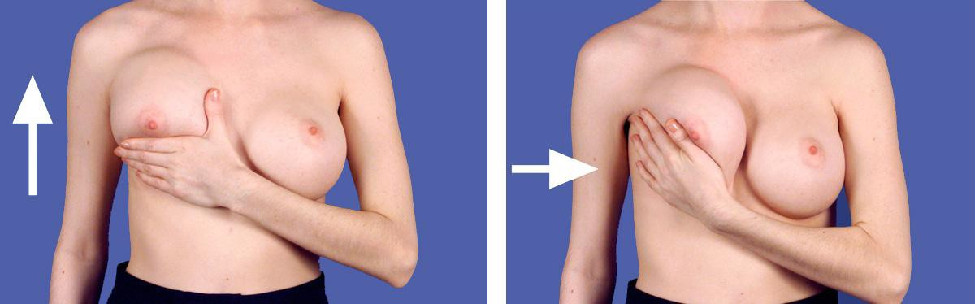

(One exercise includes both directions)

10 exercises 3 times daily for the first 6 months 10 exercises 2 times daily for the next 6 months 10 exercises one time daily for life

Please visit Dr. Ip’s website at www.surgery-plasticsurgeon.com for additional information on plastic surgery and wellness.

Newport Beach (949) 548-0300
Park Avenue NYC (855) 742-8800
Dr. T. Y. Steven Ip's Cell (949) 212-1619

